1. **Create a report that shows the product name and supplier id for all products supplied by Exotic Liquids, Grandma Kelly’s Homestead, and Tokyo Traders.**

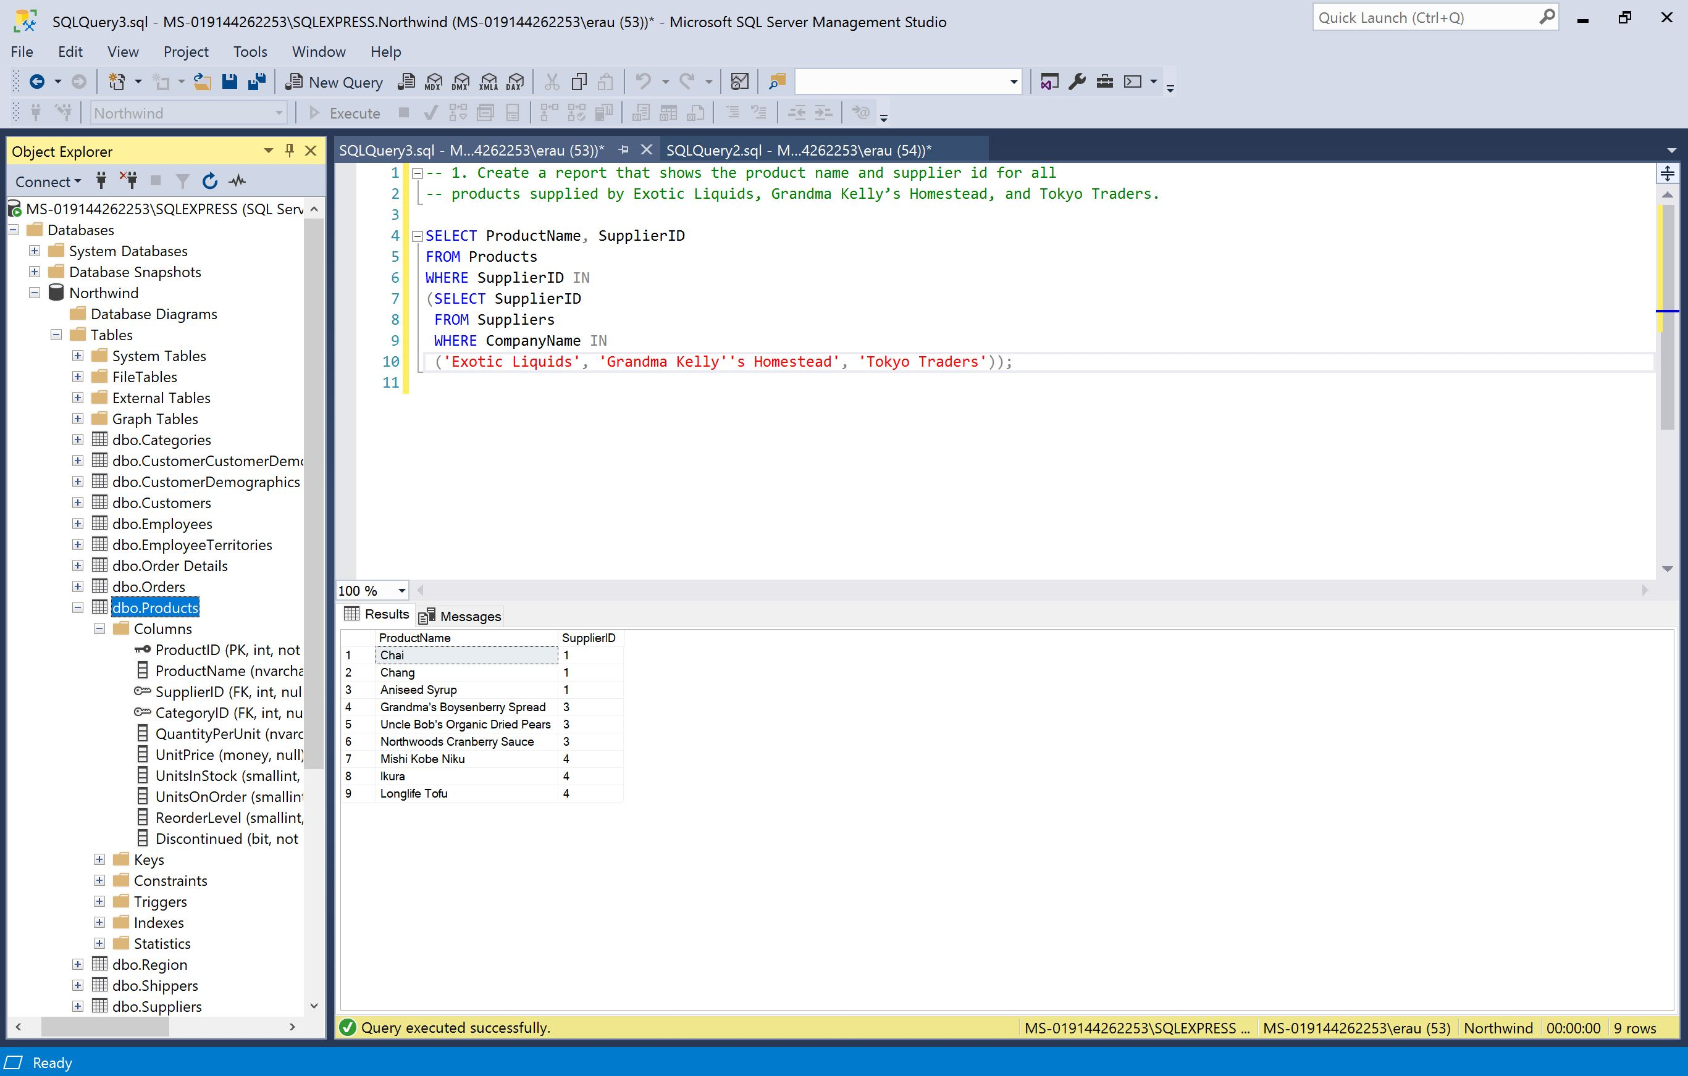

1. **Create a report that shows all products by name that are in the Seafood category.**

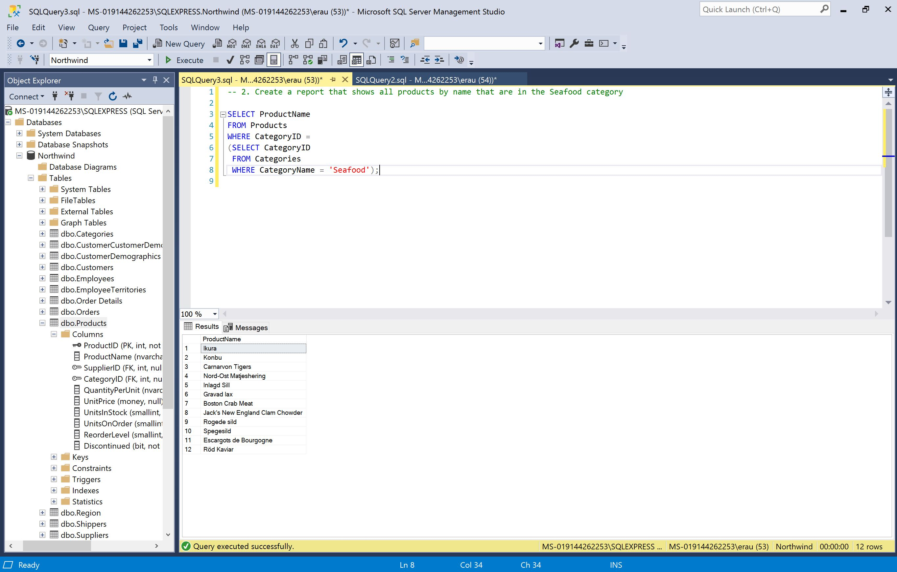

1. **Create a report that shows all companies by name that sell products in CategoryID 8.**

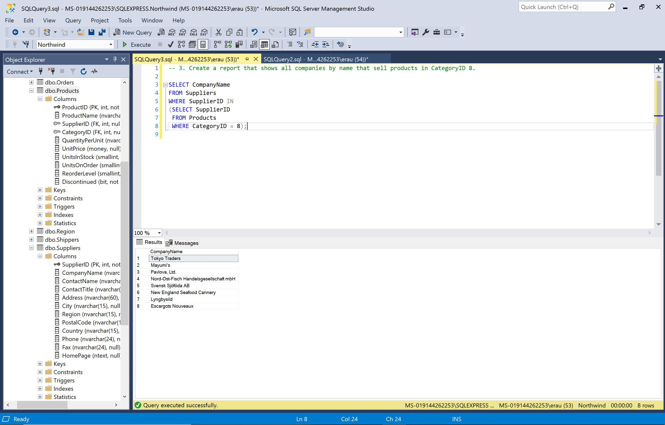

1. **Create a report that shows all companies by name that sell products in the Seafood category.**

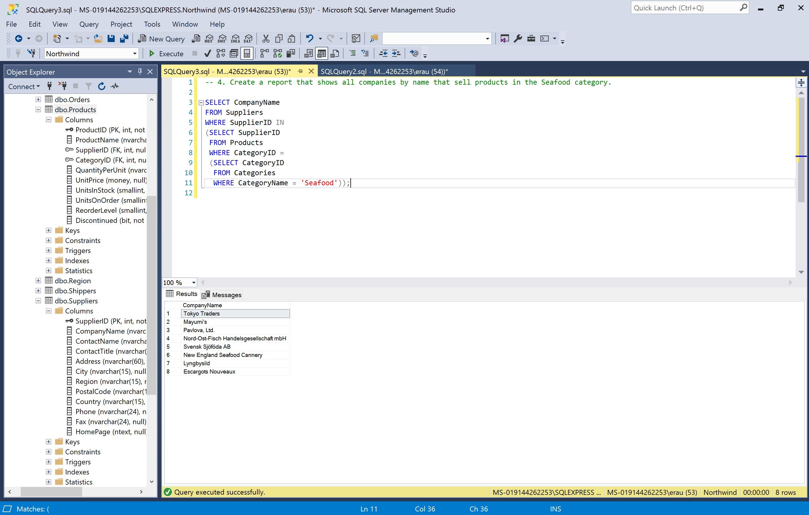

1. **Create a report that lists the ten most expensive products.**

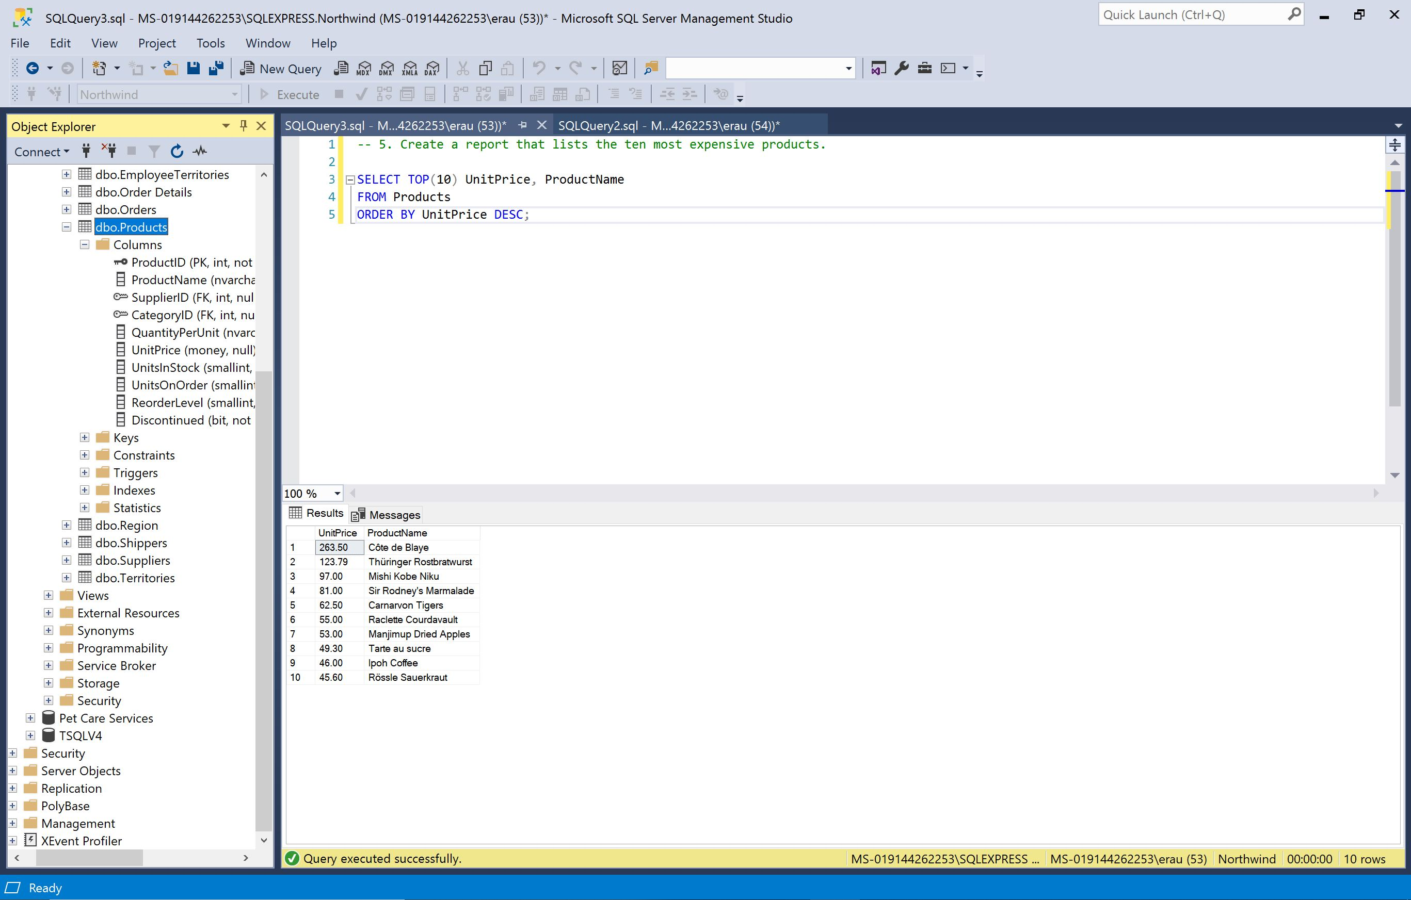

1. **Create a report that shows the date of the last order by all employees.**

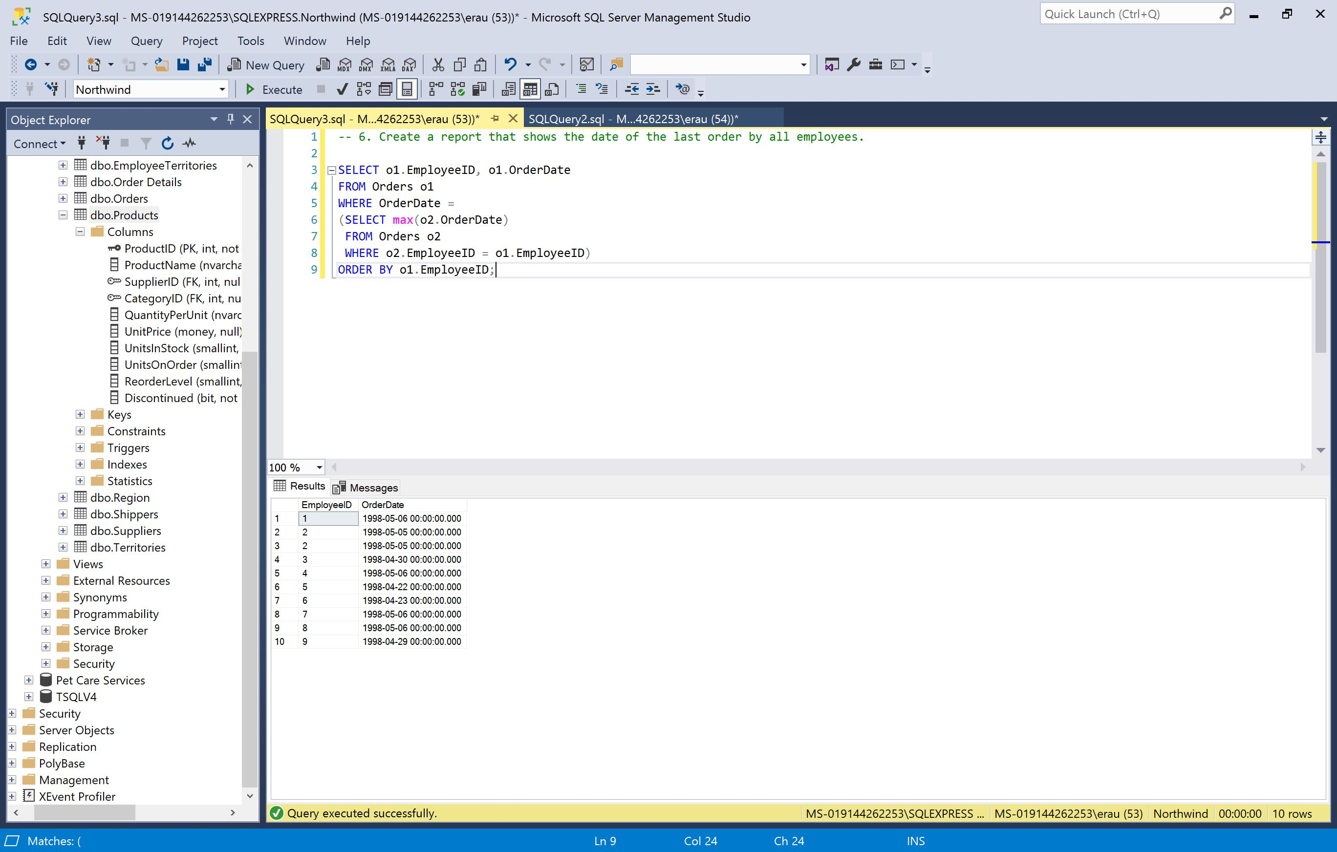

**TSQLV4**

**1. Return all orders placed on the last day of activity from Orders Table**

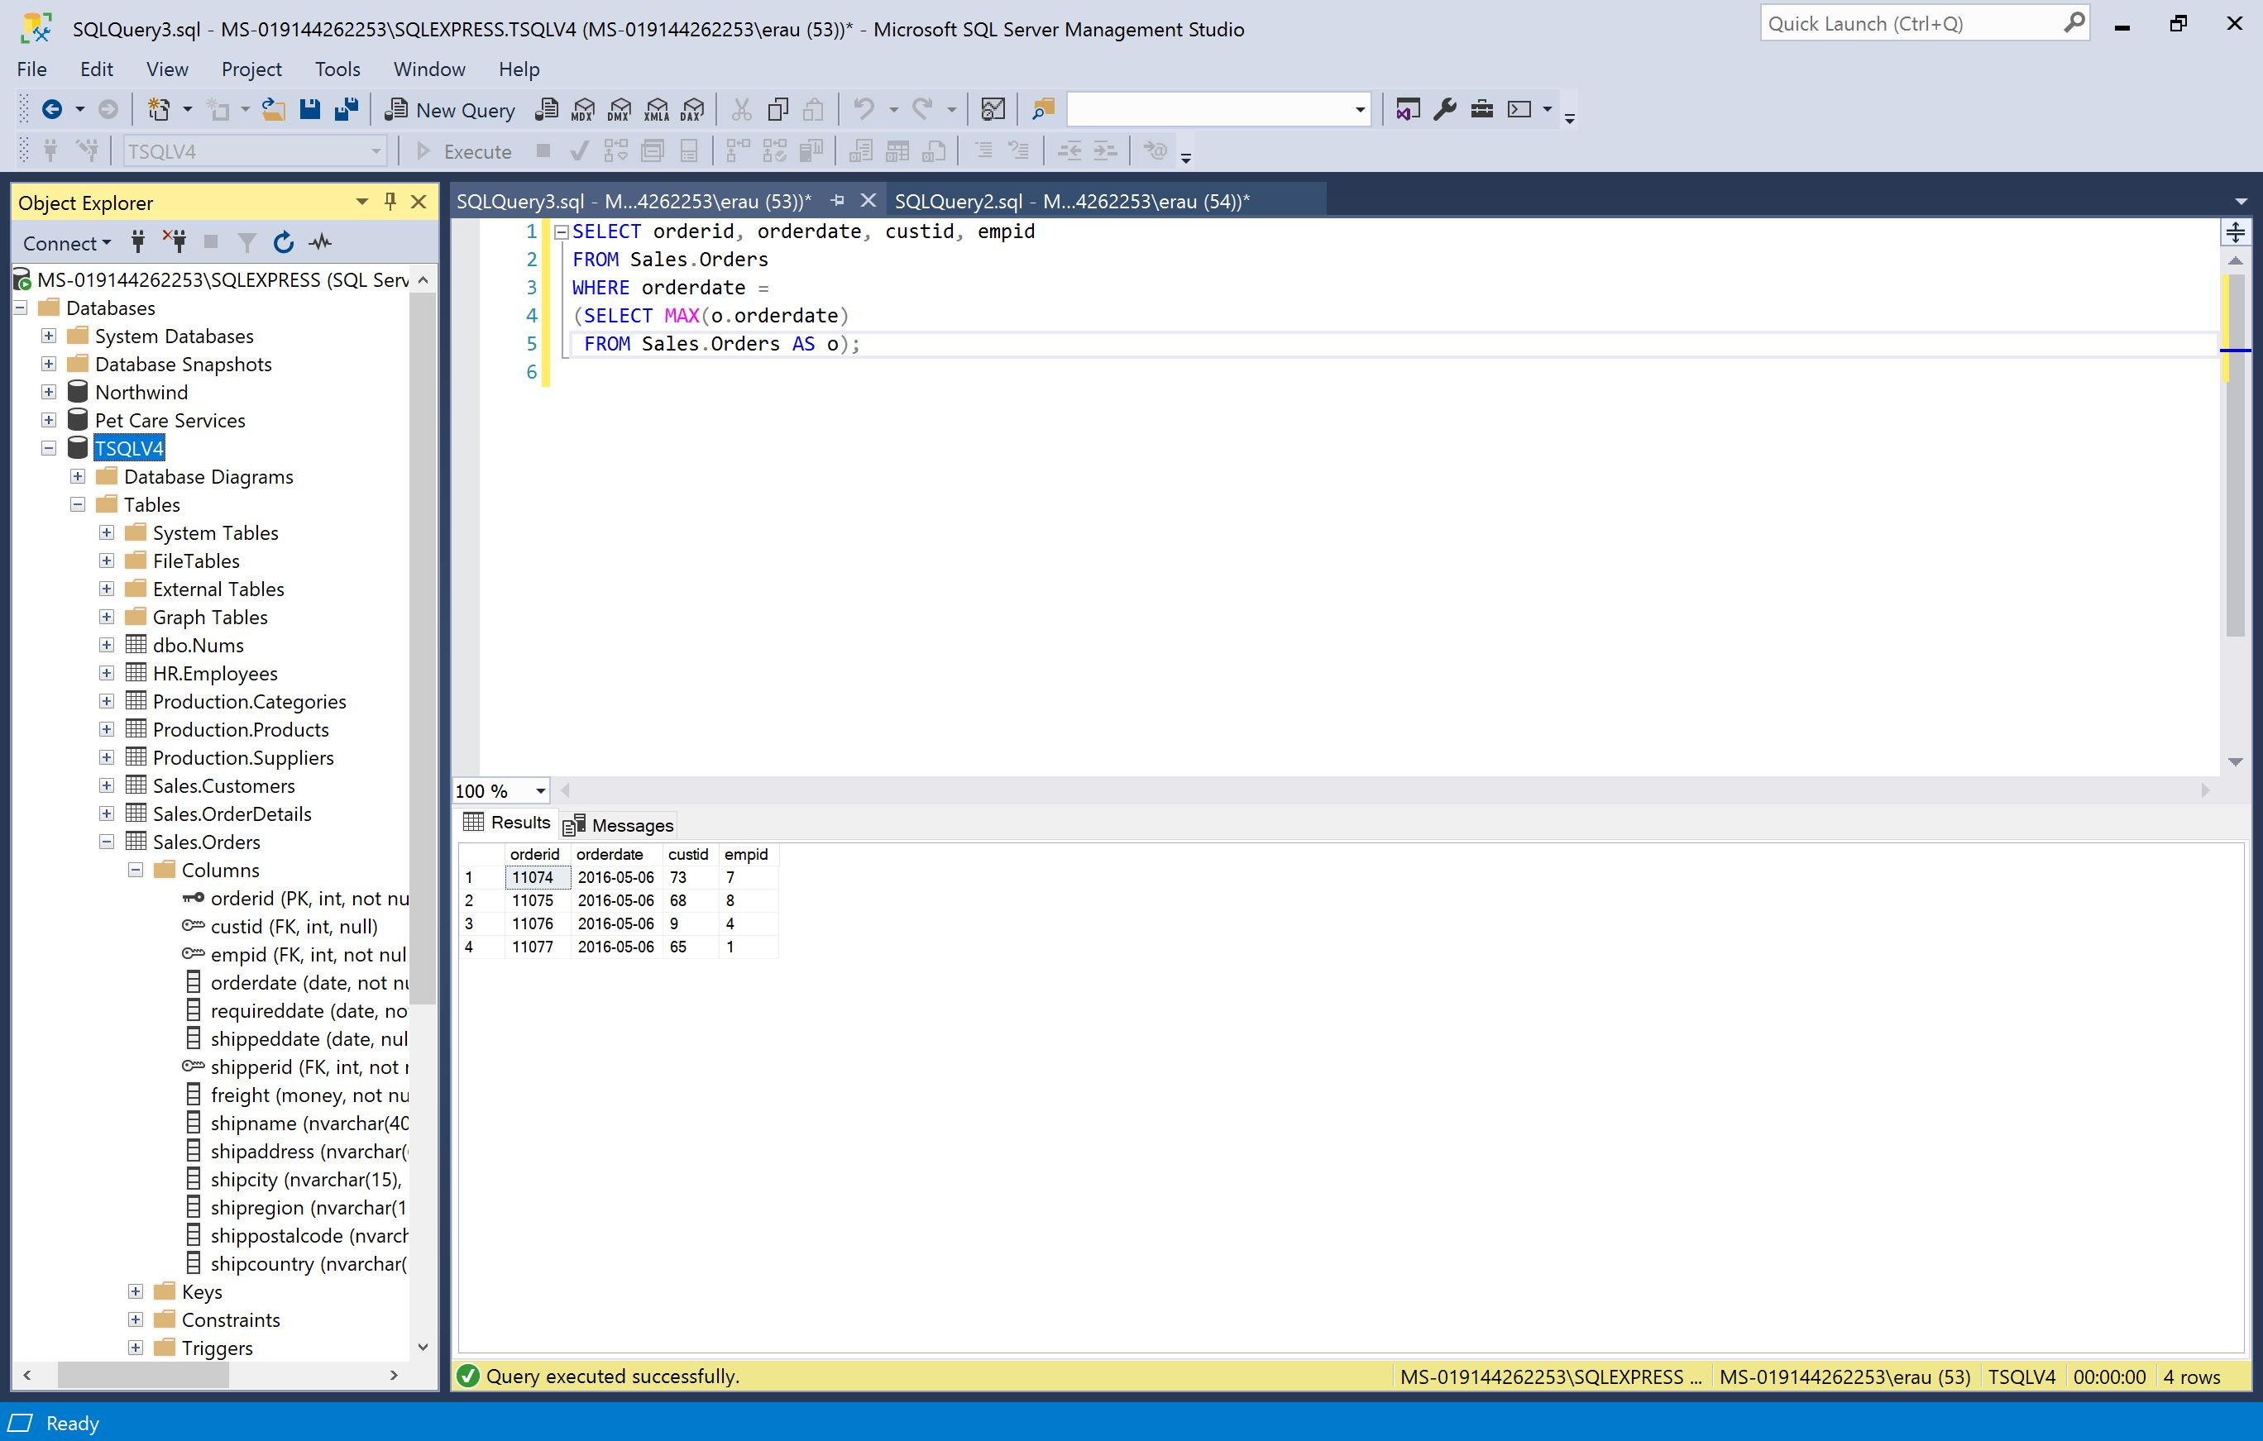

**2. Return all orders placed by the customer(s) who placed the highest number of orders.**

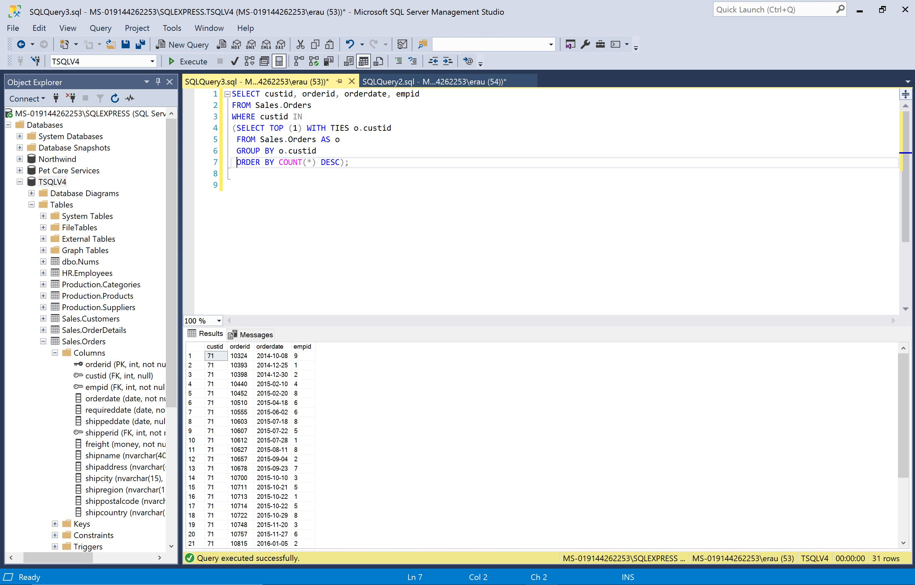

**3. Return employees who did not place orders on or after May 1, 2016**

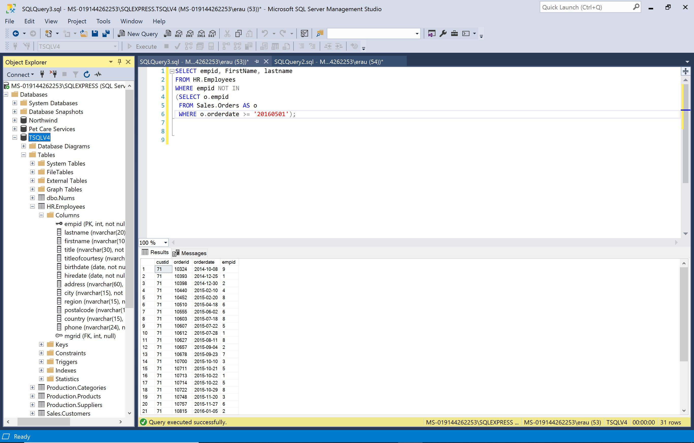

**4. Return countries where there are customers but not employees**

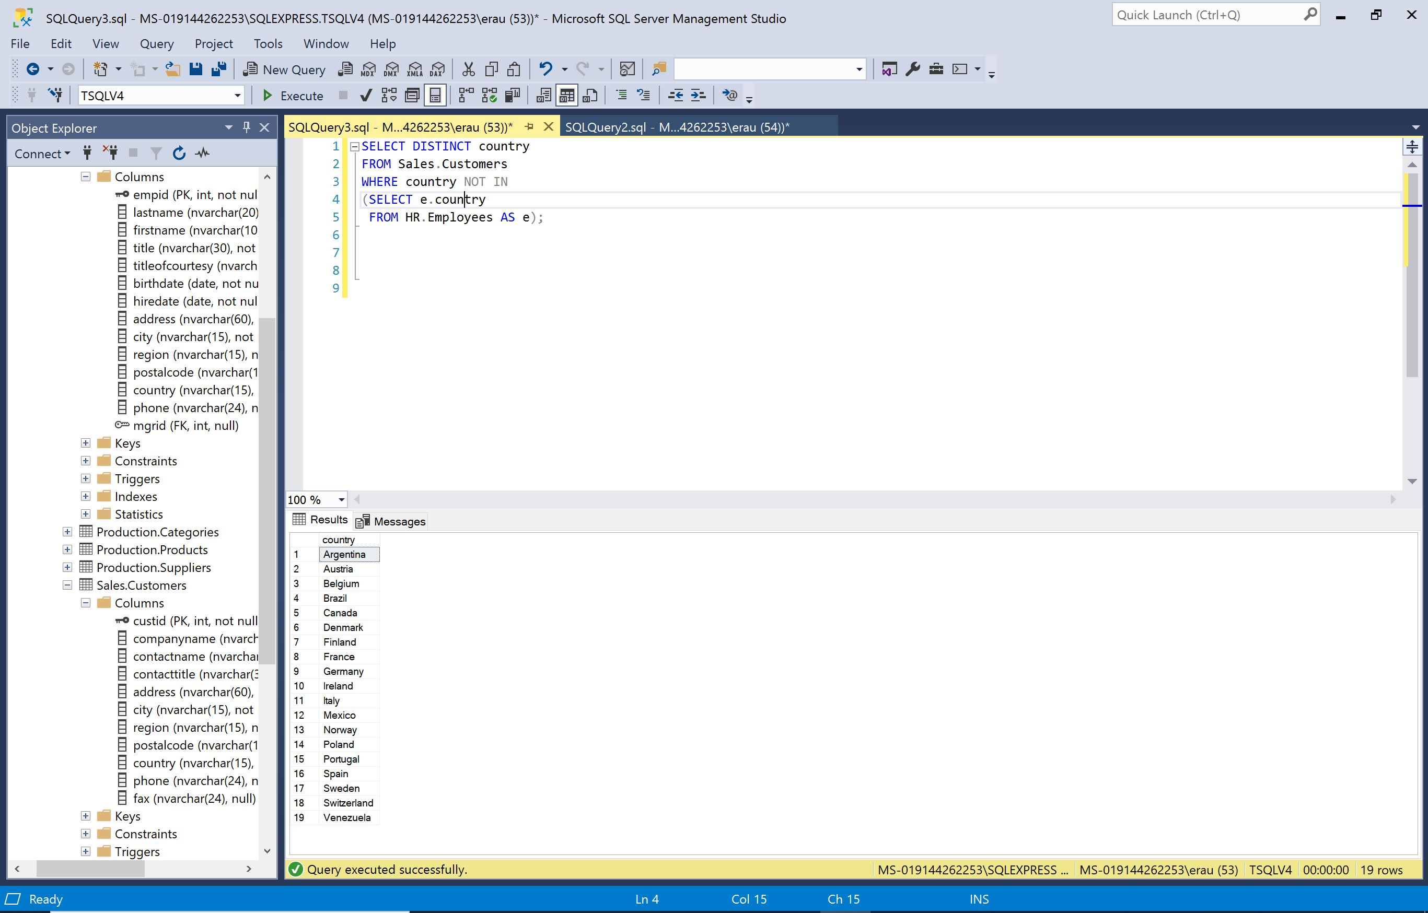

**5. Return for each customer all orders placed on the customer’s last day of activity**

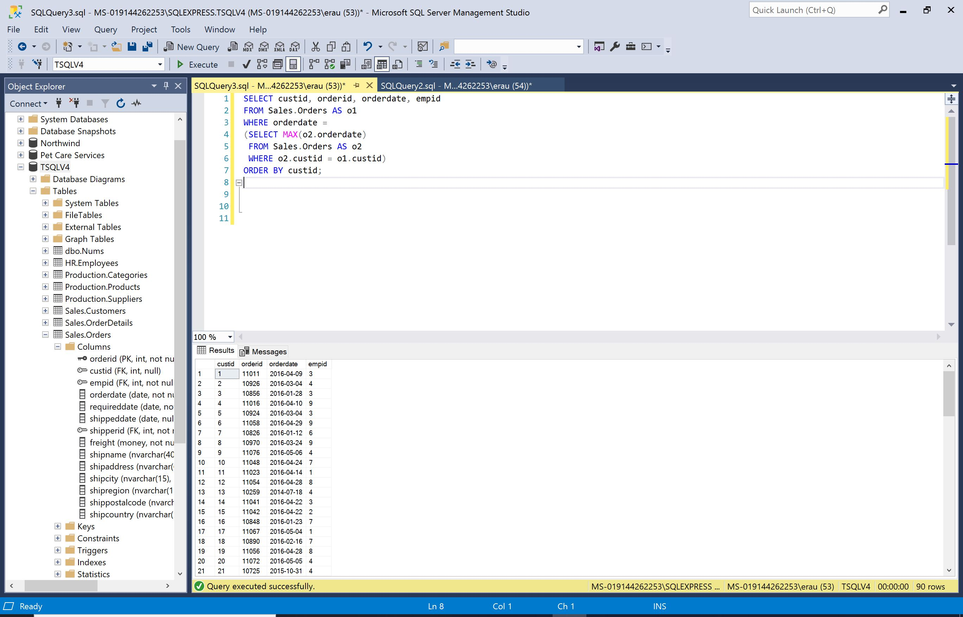

**6. Return customers who placed orders in 2015 but not in 2016**

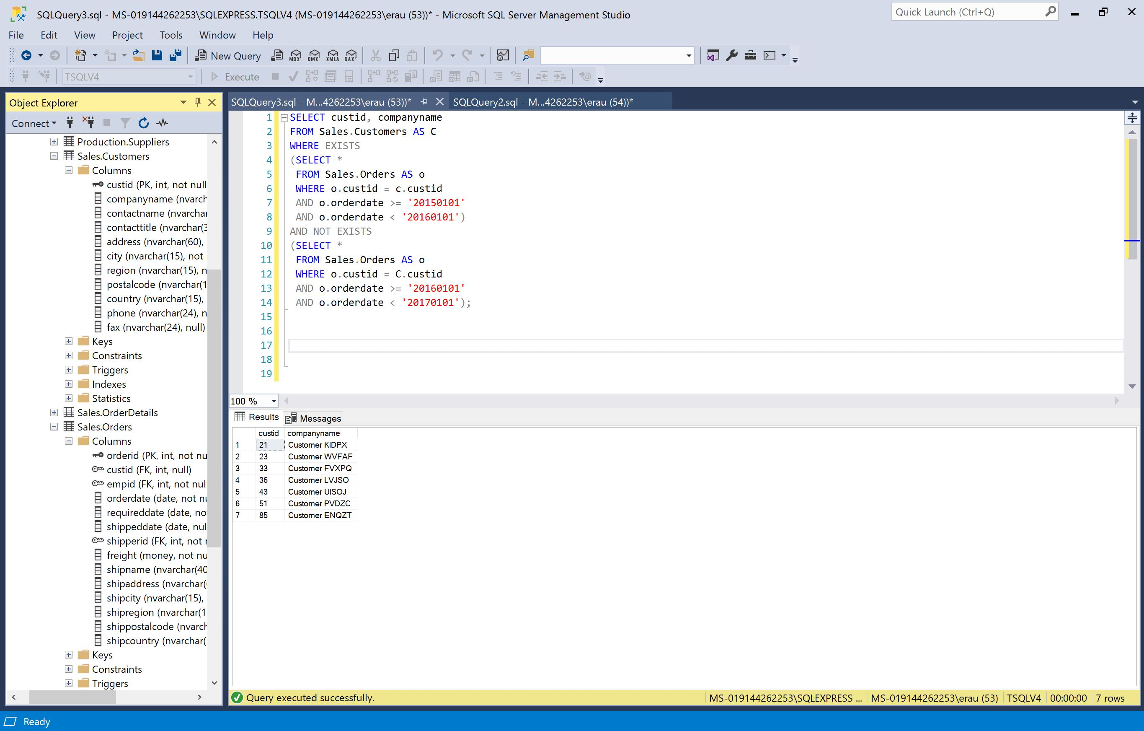

**7. Return customers who ordered product 12**

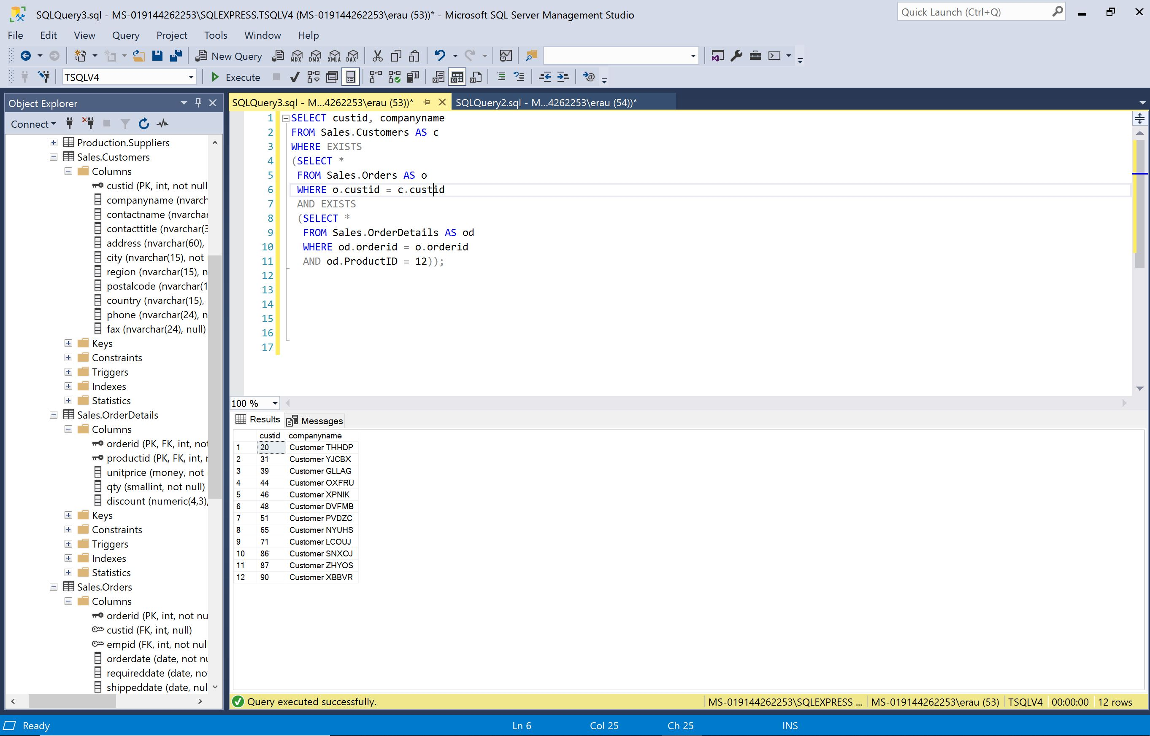

**8. Calculate a running-total quantity for each customer and month:**

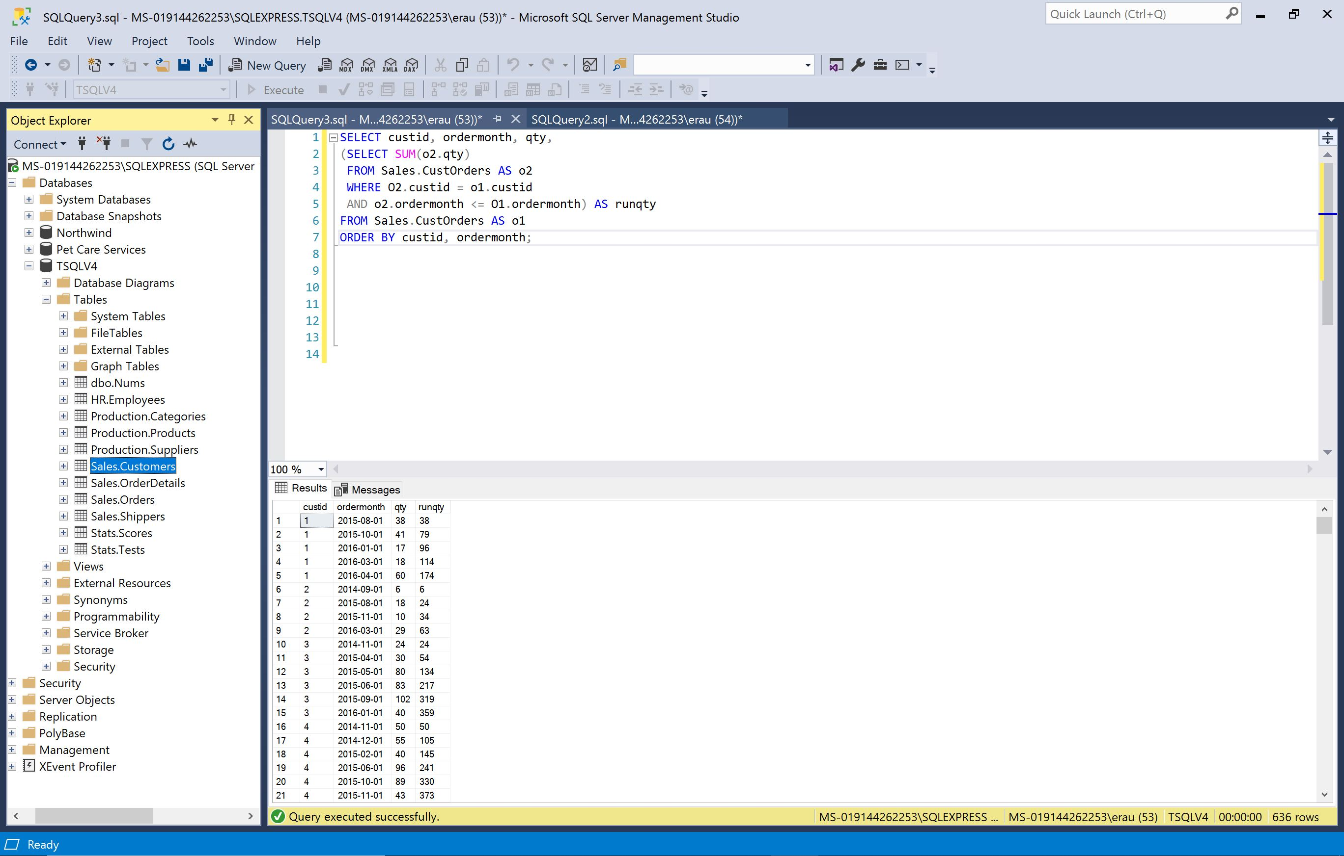

**9. Explain the difference between IN and EXISTS**

The main difference between IN and EXISTS is when focusing on the null while using the negative form NOT. When using the NOT IN form the null will be discarded. The NOT EXISTS return the data of the null

**10. Write a query that returns for each order the number of days that passed since the same customer’s previous order. To determine recency among orders, use orderdate as the primary sort element and orderid as the tiebreaker**

